Press Office 14/07/2021

VERDI’S REQUIEM, A MONUMENTAL WORK LIKE PAESTUM AND POMPEII, AT THE 98th ARENA DI VERONA OPERA FESTIVAL
The Orchestra and Chorus of the Fondazione Arena di Verona are lined up in their entirety for the only performance of Giuseppe Verdi’s spectacular and human sacred masterpiece.
The digital sets highlight the timeless landscapes of the Archaeological Parks of Paestum and Velia and of Pompeii, with the patronage of the Ministry for Culture.
Gerzmava, Margaine, Pretti and Pertusi debut at the Arena with conductor Speranza Scappucci

VERDI REQUIEM
Sunday 18th July - 9:30 pm

Arena di Verona

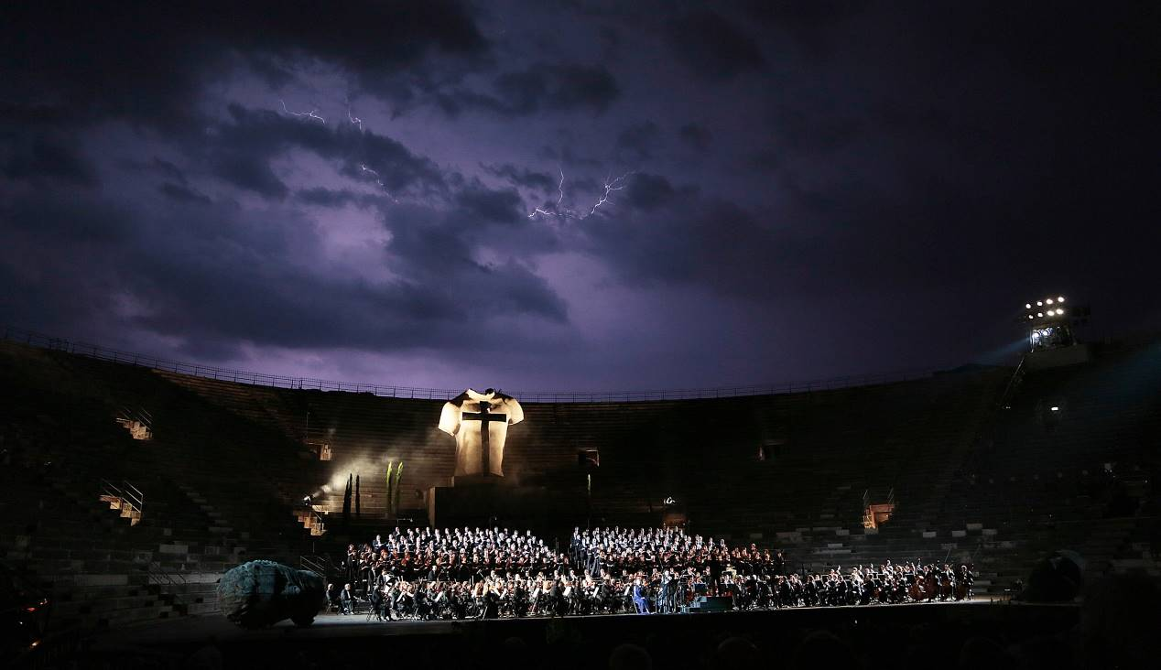
Lightning flashes on the last Messa da Requiem at the Arena di Verona, 2013 © Ennevi/Fondazione Arena di Verona
Almost ten years after its last performance inside the age-old walls of the Arena, the colossal Messa da Requiem by Giuseppe Verdi returns on Sunday 18th July at 9:30 pm for just one night: the concert event is conducted by Speranza Scappucci, on her Arena debut, as are Hibla Gerzmava and Clémentine Margaine, joined by Piero Pretti and Michele Pertusi. The digital sets are realized in collaboration with the Archaeological Park of Paestum and Velia and the Archaeological Park of Pompeii, key locations of past ages where time has come to a halt.

”Verdi’s Requiem is not a mass for death, but for life”.
Charles Osborne

Conceived to commemorate Alessandro Manzoni, Verdi’s Requiem saw the light of day on 22nd May 1874 in the Milan’s San Mark’s church, on the occasion of the first anniversary of the death of the great author. However, the first drafts of the closing Libera me date back to a few years before, and precisely at the collective mass in honour of Rossini, written with twelve other composers in 1869 but never performed: from there it grew into what was to remain opera genius Verdi’s only large sacred symphonic-choral work. The Italian and European performances that followed, all enormously successful and often conducted by the composer himself, began a debate that continues to this day on the nature of the work’s more theatrical or more sacred nature: one thing is certain: with his personal language and a miraculous inspiration, Verdi was able to instil it with a profoundly human feeling that is recognizable and touching, portraying doubt, consternation and the search for sense while unprecedented sonic landscapes alternate the overwhelming fury of the day of judgment with sonic oases that invoke eternal peace.
After the last performance in 2013, Fondazione Arena di Verona has programmed Verdi’s Requiem as a concert-event for the 98° Opera Festival, 120 years after the death of its composer, strongly desiring it in addition to the programme originally conceived for 2020: the world’s most suggestive stage under the stars will host the Chorus directed by Vito Lombardi and the Arena Orchestra with top-grade voices on the international scenario and conductor Speranza Scappucci, on her debut at the amphitheatre, as well as being the first Italian female conductor on the Arena’s podium. The Rome-born conductor has a cosmopolitan training, regularly conducts symphonic and operatic repertoire in theatres and concert halls in Vienna, Liege, Paris, Rome, Budapest, Dresden, Barcelona, Zurich, Tokyo, Los Angeles and New York, and brings her intimate interpretation of the Messa da Requiem to Verona with the profound emotion of her personal debut and the symbolic importance that the Verdi masterpiece assumes in this period. The female singers are also debuting in Verona on the same evening: Russian soprano Hibla Gerzmava, among the world’s most sought-after prima donnas for spinto repertoire, and young French mezzo-soprano Clémentine Margaine. With them, as far as the male singers are concerned, two of today’s most refined Verdi voices: tenor Piero Pretti and bass Michele Pertusi.
Continuing the ideal journey in Italy under the banner of Beauty, Verdi’s monumental sonic landscapes are echoed by the equally monumental digital sets conceived by Fondazione Arena di Verona with video design by D-wok and above all the collaboration of two prestigious institutions for the images that are processed and reproduced on the impressive 400 square metres of LED wall, in a continuous synaesthetic exchange of great emotions.
Federico Sboarina, Verona’s Mayor and President of the Fondazione Arena, expresses his gratitude for the work done by the Fondazione: “In a year such is this, through the desert left by the pandemic in the world of work, tourism, culture and entertainment, the Arena di Verona has become a symbol of rebirth and recovery, in spite of all the difficulties past and present, the attracting the attention of citizens, tourists, entrepreneurs and institutions, who have rallied round the theatre and its activities. Thanks to the passion shown by all of them, and thanks to the responsibility shared by this management since its was appointed in a precarious situation such as 2018, Fondazione Arena has managed to do something that was apparently impossible. This Requiem with the images of Paestum and Pompeii add an important element to the Festival in the project of global recovery and the process of collaboration with Italy’s institutions, of which the Ministry for Culture is also particularly proud.”
Cecilia Gasdia, General Manager and Artistic Director of the Fondazione Arena di Verona, explains, ”With the patronage of the Ministry for Culture for this special 2021 Festival, we knew that the ideal collaborators for the Messa da Requiem would have been the locations in which the passage of man’s genius is most evident yet far-off, which we recognize with admiration and identification and where it was crystallized by tragedy and passing time: this is what can be felt in the splendid archaeological parks of Paestum and Pompeii, extremely different and for this reason put side by side by us in the digital set of the Gala, on the same wavelength as the music composed by Verdi - impressive and spectacular but, above all, real.”
Capaccio-Paestum’s Mayor Franco Alfieri states, “With the evening of the 98th Arena di Verona Opera Festival dedicated to Verdi’s Requiem, a collaboration begun more than a year ago takes form, between two locations geographically far away but united by an ideal thread made of monumentality and beauty. Seeing the timeless treasures of our Paestum being used as digital scenery at the concert event conducted by Speranza Scappucci fills us with pride and joy and strengthens the awareness that this is just the first step of a long profitable journey.”
”The Arena di Verona is a great driving force for culture that involves all Italy’s excellences in an interactive promotion process. The suggestive images of Paestum and its temples, which will form the background for Verdi’s Requiem, like those of Pompeii, are symbols and expressions of the beauty of Italy’s great heritage”, states Massimo Osanna, General Manager of the Museums and Avocant General Manager of the Archaeological Park of Paestum and Velia. ”Thanks the collaboration between institutions and with the use of digital technology, it is possible for cultural sites to be appreciated by numerous people simultaneously."​
“The images of Pompeii stand alongside the immortal work of the Requiem with naturalness. Both have a status of eternity which they have in common with their reference to the meaning of life and death, of man’s fragility”, states Gabriel Zuchtriegel, General Manager of the Archaeological Park of Pompeii. ”The immensity of great works must be acknowledged, connected and exalted by their reciprocal meeting.
Italy’s artistic and musical heritage is unique and must be celebrated. Institutions are for safeguarding, but also for highlighting and promoting the extraordinary nature of this treasure. In this sense, the Archaeological Park of Pompeii is extremely pleased to participate in this special artistic event.”

The Verdi Requiem gala will be performed without intervals and last approximately 90 minutes. Seats are still available in several sectors. Prices from € 16 to € 150

For info and tickets: www.arena.it
and Facebook, Twitter, Instagram and YouTube #inarena social channels.

Special thanks go to all our sponsors, who have confirmed their valuable contribution to supporting Fondazione Arena and its prestigious Festival, even in this difficult period. First of all, Unicredit, who has been alongside our theatre for over 25 years, in the role of main sponsor, manager of our electronic ticket office and partner in all the Festival’s promotion activities. We also thank Calzedonia, Volkswagen Group Italia, DB BAHN and RTL 102.5 and welcome Pastificio Giovanni Rana among our sponsors. A special mention also goes to all the companies, entrepreneurs, professionals and private individuals who participated in the fundraising campaigns “67 columns for the Arena di Verona” and #iosonolarena, run in recent months by Fondazione Arena.

Info

Fondazione Arena di Verona Press Office
Via Roma 7/D, 37121 Verona
Tel. (+39) 045 805.1861-1905-1891-1939-1847
ufficio.stampa@arenadiverona.it - www.arena.it

Press and Media Advisors Alessia Cappelletti with Marina Nocilla

consulenti@capelletti-moja.com
Tel. +39 347 5801910 / Tel. +39 338 7172263

Ticket Office
Via Dietro Anfiteatro 6/B, 37121 Verona
Tel. (+39) 045 59.65.17 - fax (+39) 045 801.3287
biglietteria@arenadiverona.it - www.arena.it
Call center (+39) 045 800.51.51
Advance ticket sales Geticket
Prices from € 16 to € 150

Sunday 18th July - 9:30 pm

Verdi Requiem
Conductor Speranza Scappucci

Soprano Hibla Gerzmava
Mezzo-soprano Clémentine Margaine
Tenor Piero Pretti
Bass Michele Pertusi

FONDAZIONE ARENA DI VERONA ORCHESTRA AND CHORUS
Video design and digital sets by D-wok

