Press Office 03/09/2021

FONDAZIONE ARENA DI VERONA ANNOUNCES
THE 99th OPERA FESTIVAL
Tickets on sale from 10th September with special prices

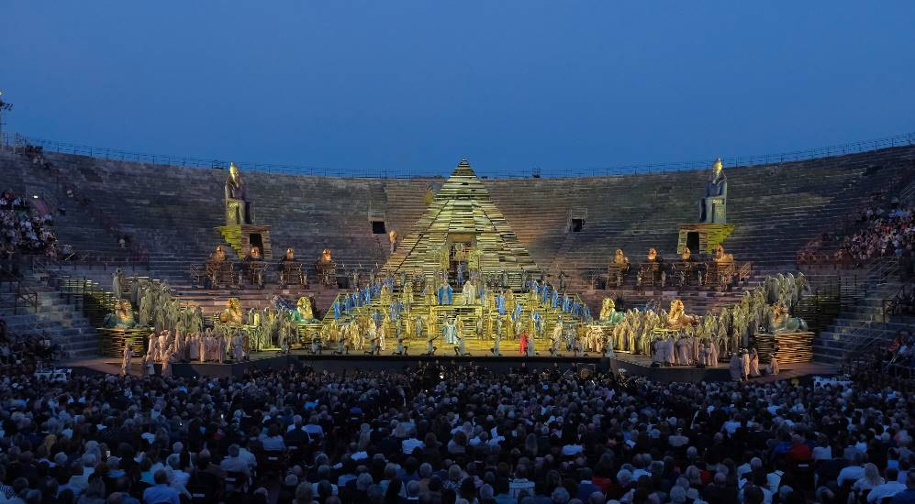
Foto Ennevi

A year from the eagerly expected 100th edition, the 99th Arena di Verona Opera Festival is preparing for the return of large-scale events, on stage for 45 evenings with 5 opera productions and 3 special events from 17th June to 4th September. The magic of the world’s largest open-air theatre will be back thanks to the artists and technicians of the Fondazione Arena with international conductors and artists in the most important and popular operas.
The curtain will rise on the 2022 Festival on 17th June with a spectacular historic return: the Carmen by Georges Bizet in the legendary production which was in fact the 1995 Arena debut at the amphitheatre of Franco Zeffirelli, and will be proposed in the best synthesis of the various editions staged at the Arena di Verona, narrating the strongest passion with the background of a multi-coloured Seville teeming with life, and featuring convincing realism with a cinematographic slant. Including the inauguration, the French masterpiece will be staged for 9 evenings.
Further performances: 24, 30 June (9:15 pm) - 14, 21, 31 July (9:00 pm) – 11, 14, 27 August (8:45 pm)
The Festival’s second opera will be Giuseppe Verdi’s Aida, the top-ranking opera and symbol of the Arena right from the first edition of 1913, which will also have the honour of bring staged on the last evening. Aida will be performed from 18th June on 11 dates in the classic production also conceived by Franco Zeffirelli which recreates a glittering dreamlike Ancient Egypt, enriched by the costumes of Anna Anni.
Further performances: 23 June 9:15 pm - 3, 8, 16, 24, 28 July 9:00 pm – 5, 21, 28 August 8:45 pm – 4 September 8:45 pm
The third production being staged on the immense Arena stage is another Verdi masterpiece, an epic choral drama, scheduled for 8 performances from 25th June, Nabucco, which will be proposed in the imposing production inspired by the Italian Risorgimento which inaugurated the 2017 Festival, with direction and costume design by Arnaud Bernard and set design by Alessandro Camera. Further performances: 1, 7, 10, 23, 29 July (9:00 pm) - 18 August (8:45 pm) - 3 September (8:45 pm).
The fourth opera of the 2022 Festival was expressly conceived as the artistic synthesis and legacy of its creator dedicated to the Arena di Verona, La Traviata by Verdi; opera’s most popular love story will return on 2nd July for 8 performances with the marvellous production created for the 2019 Festival by Franco Zeffirelli, who was responsible for the direction and set design, and costumes by prize-winning designer Maurizio Millenotti.
Further performances: 9, 15, 22, 30 July (9:00 pm) - 6, 20 August (8:45 pm) – 1 September (8:45 pm).
The last debut of the Festival will be the return of the spectacular “China in the days of fables” in Turandot by Puccini, on-stage for 6 performances from 7th August. The ideal production for this captivating fable is the magnificent one by maestro Franco Zeffirelli (direction and set design), with the sumptuous costumes by Academy Award winner Emi Wada.
Further performances: 10, 13, 19, 26 August at 8:45 pm – 2 September at 8:45 pm.
The 99th Festival will also be further enriched by three unique special events: the first is Roberto Bolle and Friends, a true celebration of Dance in all its forms, which will return for an unmissable appointment on 20th July at the Arena di Verona; this will be followed by the monumental symphonic and choral concert of Carmina Burana on 12th August, a tribute to Ezio Bosso, exactly three years from his concert at the Arena and lastly, for a single extraordinary date, the highly acclaimed Plácido Domingo will perform some of the most important roles of the Busseto genius, in an opera gala in scenic form on 25th August. the Domingo in Verdi Opera Night.
Tickets for the shows of the 99th Arena di Verona Opera Festival will be on sale from 10th September with prices from € 28 to € 300, exceptionally for some sectors at special prices until 24th December; a new feature for 2022 is the introduction of the new 1st sector stalls silver seats.
Fondazione Arena di Verona hopes to be able to welcome the largest possible number of spectators as soon as possible: until then, respecting its audiences and anti-CoVid19 regulations, tickets are on sale until the maximum permitted capacity is reached.
The Arena di Verona also awaits its public on the renewed Web site www.arena.it and its Facebook, Twitter, Instagram and YouTube social channels.
Info
Fondazione Arena di Verona Press Office
Via Roma 7/D, 37121 Verona
Tel. (+39) 045 805.1861-1905-1891-1939
ufficio.stampa@arenadiverona.it - www.arena.it

Ticket Office
Via Dietro Anfiteatro 6/B, 37121 Verona
Tel. (+39) 045 59.65.17 - fax (+39) 045 801.3287
biglietteria@arenadiverona.it - www.arena.it
Call center (+39) 045 800.51.51
Advance ticket sales Geticket

Press and Media Advisors Alessia Cappelletti with Marina Nocilla

consulenti@capelletti-moja.com
Tel. +39 347 5801910 / Tel. +39 338 7172263
ARENA DI VERONA
99th Opera Festival
From 17th June to 4th September

Carmen
Georges Bizet | Direction Franco Zeffirelli
17, 24, 30 June - 9:15 pm
14, 21, 31 July - 9:00 pm
11, 14, 27 August - 8:45 pm

Aida
Giuseppe Verdi | Direction Franco Zeffirelli
18, 23 June - 9:15 pm
3, 8, 16, 24, 28 July – 9:00 pm
5, 21, 28 August - 8:45 pm
4 September - 8:45 pm

Nabucco
Giuseppe Verdi | Director Arnaud Bernard
25 June - 9:15 pm
1, 7, 10, 23, 29 July – 9:00 pm
18 August - 8:45 pm
3 September - 8:45 pm

La Traviata
Giuseppe Verdi | Direction Franco Zeffirelli
2, 9, 15, 22, 30 July – 9:00 pm
6, 20 August - 8:45 pm
1 September - 8:45 pm

Roberto Bolle and Friends
20 July - 9:15 pm

Turandot
Giacomo Puccini | Direction Franco Zeffirelli
7, 10, 13, 19, 26 August - 8:45 pm
2 September - 8:45 pm

Carmina Burana
12 August - 8:45 pm

Domingo in Verdi Opera Night
25 August - 9:00 pm
PRICES
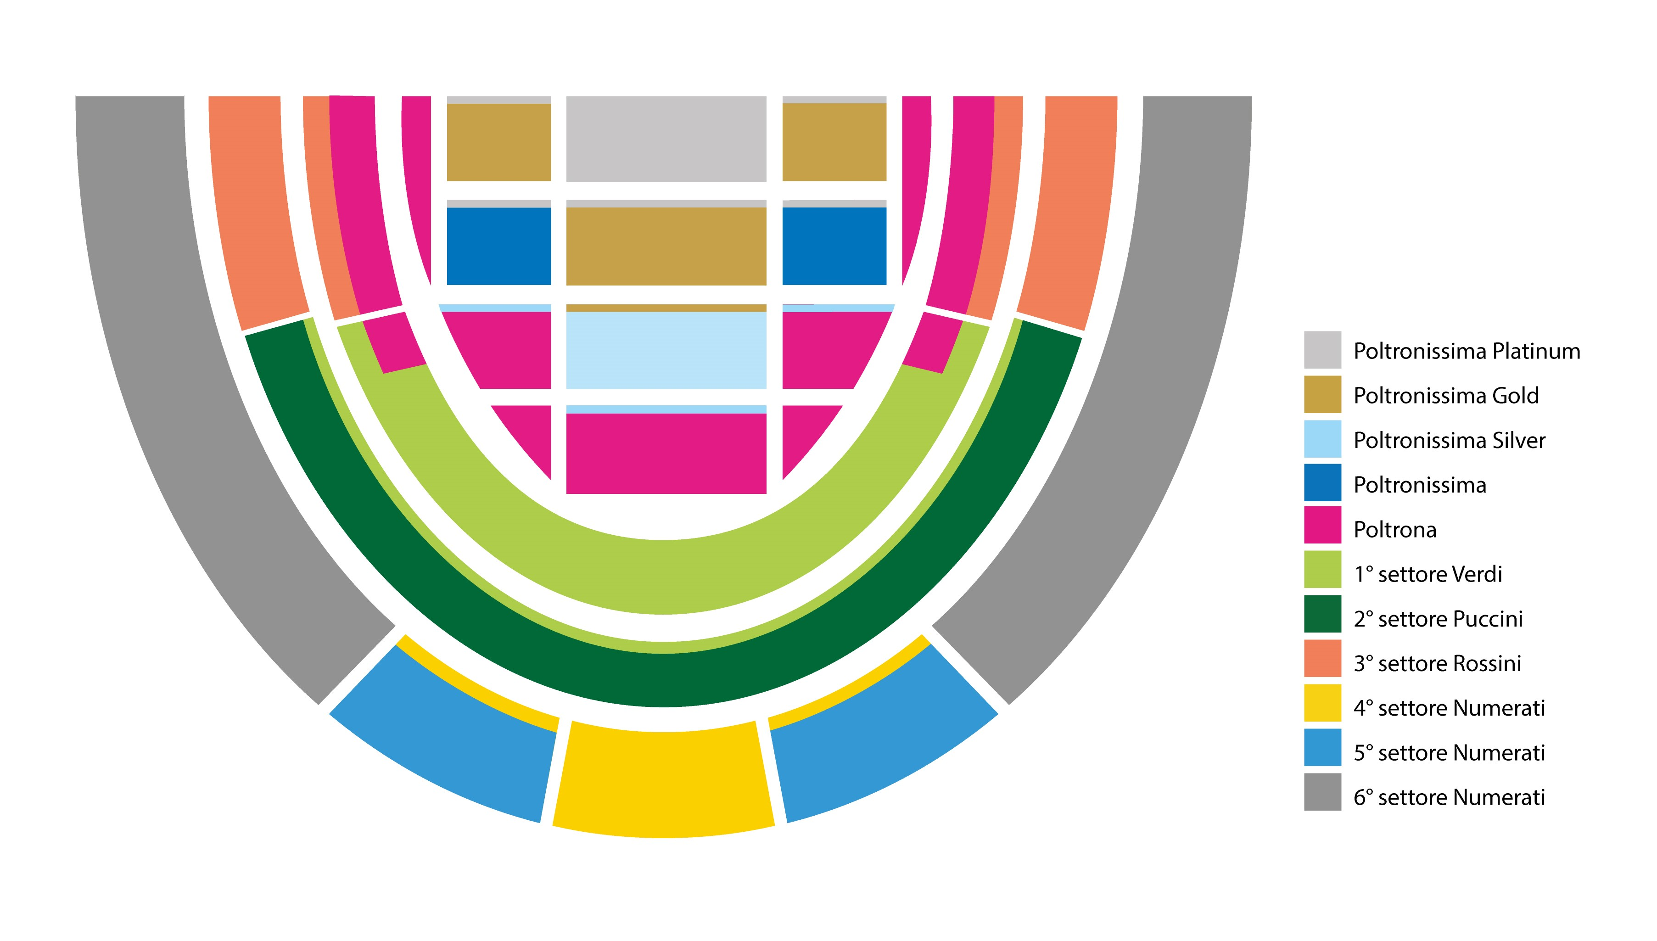

SPECIAL PRICES UNTIL 24/12/2021 / PRICES FROM 25/12/2021

PREMIÈRES and GALA EVENINGS
Carmen 17/6 · Aida 18/6 · Gala Domingo in Verdi Opera Night 25/8
SEATING SECTOR Prices
1st SECTOR STALLS PLATINUM € 300.00
1st SECTOR STALLS GOLD € 240.00
1st SECTOR STALLS SILVER € 210.00
1st SECTOR STALLS € 185.00
2nd SECTOR STALLS € 155.00
2nd SECTOR STALLS - reduced rate € 140.00
“VERDI” 1st SECTOR € 132.00
“PUCCINI“ 2nd SECTOR € 105.00
“PUCCINI” 2nd SECTOR - REDUCED RATE € 95.00
“ROSSINI“ 3rd SECTOR € 79.00
“ROSSINI” 3rd SECTOR - REDUCED RATE € 71.00
4th SECTOR - NUMBERED SEATS ON THE STEPS € 66.00
4th SECTOR - NUMBERED SEATS ON THE STEPS - REDUCED RATE € 59.00
5th SECTOR - NUMBERED SEATS ON THE STEPS € 48.00
5th SECTOR - NUMBERED SEATS ON THE STEPS - REDUCED RATE € 43.00
6th SECTOR - NUMBERED SEATS ON THE STEPS € 35.00
6th SECTOR - NUMBERED SEATS ON THE STEPS - REDUCED RATE € 26.00

Thursday, Friday and Saturday + Open Tickets * Open Tickets: not valid for premières and Gala evenings
SEATING SECTOR Prices until 24/12/2021 Prices from 25/12/2021
1st SECTOR STALLS PLATINUM € 270.00 € 270.00
1st SECTOR STALLS GOLD € 199.00 € 216.00
1st SECTOR STALLS SILVER € 173.00 € 190.00
1st SECTOR STALLS € 150.00 € 165.00
2nd SECTOR STALLS € 126.00 € 137.00
2nd SECTOR STALLS - reduced rate € 114.00 € 124.00
“VERDI” 1st SECTOR € 108.00 € 117.00
“PUCCINI“ 2nd SECTOR € 86.00 € 94.00
“PUCCINI” 2nd SECTOR - REDUCED RATE € 78.00 € 84.00
“ROSSINI“ 3rd SECTOR € 65.00 € 71.00
“ROSSINI” 3rd SECTOR - REDUCED RATE € 59.00 € 64.00
4th SECTOR - NUMBERED SEATS ON THE STEPS € 54.00 € 59.00
4th SECTOR - NUMBERED SEATS ON THE STEPS - REDUCED RATE € 49.00 € 53.00
5th SECTOR - NUMBERED SEATS ON THE STEPS € 39.00 € 43.00
5th SECTOR - NUMBERED SEATS ON THE STEPS - REDUCED RATE € 35.00 € 38.00
6th SECTOR - NUMBERED SEATS ON THE STEPS € 26.00 € 32.00
6th SECTOR - NUMBERED SEATS ON THE STEPS - REDUCED RATE € 23.00 € 24.00

Wednesday and Sunday + Roberto Bolle and Friends 20/7
SEATING SECTOR Prices until 24/12/2021 Prices from 25/12/2021
1st SECTOR STALLS PLATINUM € 251.00 € 251.00
1st SECTOR STALLS GOLD € 185.00 € 201.00
1st SECTOR STALLS SILVER € 161.00 € 175.00
1st SECTOR STALLS € 137.00 € 150.00
2nd SECTOR STALLS € 116.00 € 126.00
2nd SECTOR STALLS - reduced rate € 105.00 € 114.00
“VERDI” 1st SECTOR € 99.00 € 107.00
“PUCCINI“ 2nd SECTOR € 79.00 € 86.00
“PUCCINI” 2nd SECTOR - REDUCED RATE € 71.00 € 77.00
“ROSSINI“ 3rd SECTOR € 59.00 € 65.00
“ROSSINI” 3rd SECTOR - REDUCED RATE € 53.00 € 58.00
4th SECTOR - NUMBERED SEATS ON THE STEPS € 49.00 € 54.00
4th SECTOR - NUMBERED SEATS ON THE STEPS - REDUCED RATE € 45.00 € 48.00
4th SECTOR - NUMBERED SEATS ON THE STEPS € 36.00 € 39.00
5th SECTOR - NUMBERED SEATS ON THE STEPS - REDUCED RATE € 32.00 € 35.00
6th SECTOR - NUMBERED SEATS ON THE STEPS € 25.00 € 30.00
6th SECTOR - NUMBERED SEATS ON THE STEPS - REDUCED RATE € 22.00 € 23.00

Carmina Burana 12/8
SEATING SECTOR Prices until 24/12/2021 Prices from 25/12/2021
1st SECTOR STALLS PLATINUM € 190.00 € 190.00
1st SECTOR STALLS GOLD € 145.00 € 160.00
1st SECTOR STALLS SILVER € 125.0 € 139.00
1st SECTOR STALLS € 108.00 € 120.00
2nd SECTOR STALLS € 98.00 € 107.00
2nd SECTOR STALLS - reduced rate € 89.00 € 97.00
“VERDI” 1st SECTOR € 85.00 € 91.00
“PUCCINI“ 2nd SECTOR € 69.00 € 74.00
“PUCCINI” 2nd SECTOR - REDUCED RATE € 62.00 € 67.00
“ROSSINI“ 3rd SECTOR € 51.00 € 56.00
“ROSSINI” 3rd SECTOR - REDUCED RATE € 46.00 € 50.00
4th SECTOR - NUMBERED SEATS ON THE STEPS € 46.00 € 50.00
4th SECTOR - NUMBERED SEATS ON THE STEPS - REDUCED RATE € 41.00 € 45.00
5th SECTOR - NUMBERED SEATS ON THE STEPS € 30.00 € 32.00
5th SECTOR - NUMBERED SEATS ON THE STEPS - REDUCED RATE € 27.00 € 29.00
6th SECTOR - NUMBERED SEATS ON THE STEPS € 22.00 € 28.00
6th SECTOR - NUMBERED SEATS ON THE STEPS - REDUCED RATE € 20.00 € 22.00

If necessary, Fondazione Arena di Verona reserves the right to modify this program.

